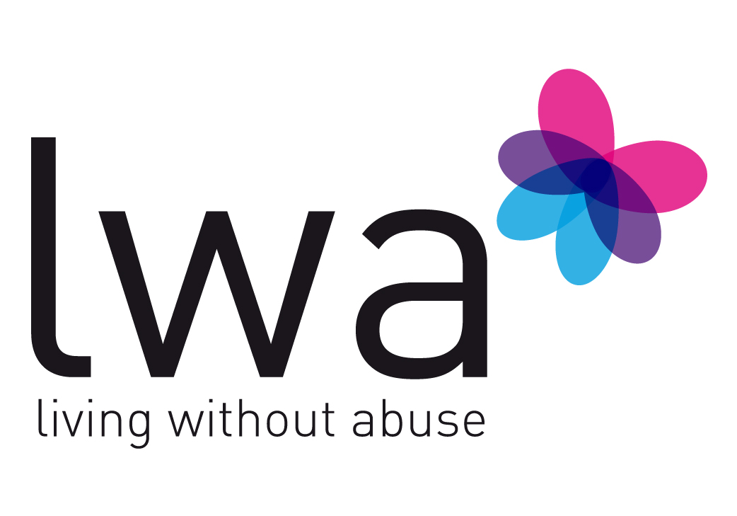

Post of Family Support Worker

Job Description

Job Title: Family Support Worker

Responsible to: Family Service Manager, and ultimately to LWA Board of
Directors.

Purpose of post: To provide support for children and young people in the Leicestershire area who are, or have been, affected by domestic abuse and/or sexual violence.

Context of post: LWA – Living Without Abuse is a registered charity and Company Limited by Guarantee. It is administered by a Board of Directors composed of women who volunteer their time and input.

LWA is a member of Women’s Aid Federation England.

LWA is a specialist woman and girls organization. Because of the nature of its work, the organization is exempt in accordance with the provisions of the Occupational Requirement (Equality Act 2010, Schedule 9 Part I). It has, however, adopted an Equal Opportunities policy, and all members of staff are required to promote these values and observe good practice guidelines in working sensitively and creatively with service clients, members of the public, volunteers, and workers in other organizations.

Duties and Responsibilities

- To deliver one-to-one support to children and young people affected by domestic abuse and/or sexual violence.

- To deliver group sessions to children and young people affected by domestic abuse and/or sexual violence.

- To support parents and carers to enhance their parenting skills.

- To deliver training and awareness sessions with local practitioners.

- To provide healthy relationship sessions in local school and youth settings.

- To create and maintain accurate client records, including:

  - referral data
  - risk assessments
  - needs assessments
  - support plans
  - safety plans
  - case notes.
  - Insights

- To maintain an appropriate level of confidentiality in all aspects of work.

- To maintain good working relationships and links with outside agencies and refer to specialist agencies where necessary.

- To actively implement and adhere to all LWA policies and procedures at all times.

- Where appropriate, to attend meetings, conferences and forums on behalf of LWA.

- To attend LWA meetings in order to advise on service issues, report on developments and requirements, and contribute to discussions affecting the organization and its clients.

- To do all else to further the aims and objectives of the organization, and to assist its Directors, paid staff and volunteers to work to the highest standards of service provision for its clients.

This job description indicates the main areas of activity of the post. From time to time, however, other tasks/duties may be required, but these will fall within the general responsibility and grade of the post.

