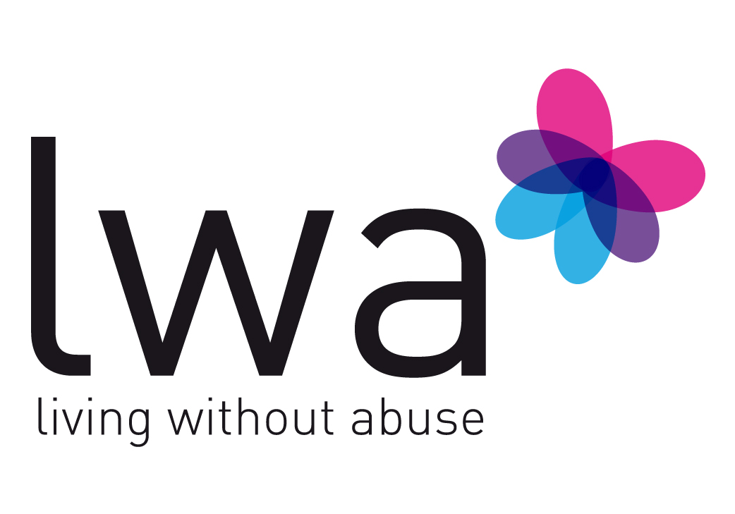

Post of Family Support Worker

Person Specification

Essential Requirements:

- A recognised qualification in social work, education, youth and community, family work, other relevant qualification and/or three years experience of working in a paid or unpaid capacity with children and young people in a group and on a one-to-one basis.

- An understanding of domestic abuse and sexual violence and the ways in which this can affect individuals.

- Experience of working with families.

- An understanding of multi-agency working, including Early Help, child protection and safeguarding procedures.

- An ability to work flexibly, as required, including evening and weekend work.

- Experience in using basic IT programmes, email and the internet.

- Good communication and interpersonal skills.

- Experience of working under pressure.

- An ability to use own initiative, and to make appropriate decisions within boundaries set by the line manager and organisational policies and procedures.

- An understanding of the importance of confidentiality in a role of this kind.

- Experience of establishing and maintaining good relationships with a wide variety of people.

- Commitment to equal opportunities practice.

- Driving licence, business insurance and ability to travel across Leicester, Leicestershire and Rutland.

In addition to the above essential requirements, the post would benefit from the following:

Desirable Attributes and Experience:

- Experience of working with people experiencing domestic abuse.
- Experience of working in the voluntary sector.
- Experience of working with families in times of crisis.
- Experience of delivering training and awareness-raising.

