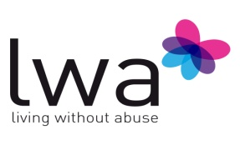

Equal Opportunities Monitoring Form
Please complete all sections below. Information received will be used for monitoring purposes and to ensure fair and equal treatment for all service users accessing the service. Please tick where applicable.
Gender
Male [ ] Female [ ]

Age Group
Under 18 [ ] 18-24 [ ]
25-29 [ ] 30-39 [ ]
40-49 [ ] 50+ [ ]

Ethnicity

White British [ ] Asian: Indian [ ]
White Irish [ ] Asian: Pakistani [ ]
White European [ ] Asian: Bangladesh [ ]
White Other [ ] Asian: Other [ ]
Mixed: White and Black Caribbean [ ] Black: African [ ]
Mixed: White and Black African [ ] Black: Caribbean [ ]
Mixed: White and Asian [ ] Black: Other [ ]
Mixed: Other [ ] Chinese [ ]
Other Prefer not to disclose [ ]

Sexual Orientation

Heterosexual [ ] Gay [ ]
Bisexual [ ] Transgender [ ]
Lesbian [ ] Prefer not to disclose [ ]

Religion (please state)

Prefer not to disclose [ ]

Disability

The Disability Discrimination Act (1995) defines a disabled person as “a person who has or has had in the past a physical or mental impairment which has a substantial and long term effect on their ability to carry out normal day-to-day activities.” Under this definition do you consider yourself to be disabled?

Yes [ ] No [ ]
If yes, please tick any categories that are applicable to you:

Physical Disability [ ] Learning Disability [ ]
Mental Health Issue [ ] Other [ ]

Thank you for taking the time to complete this form.

